CONCERNS VOICED ABOUT COLCHESTER’S PROPOSED 11,000 NEW HOUSES

At a packed meeting of the Colchester Association of Local Councils, a panel of MP’s, county and city councillors were asked questions about the 11,000 new houses planned for Colchester and surrounding countryside.

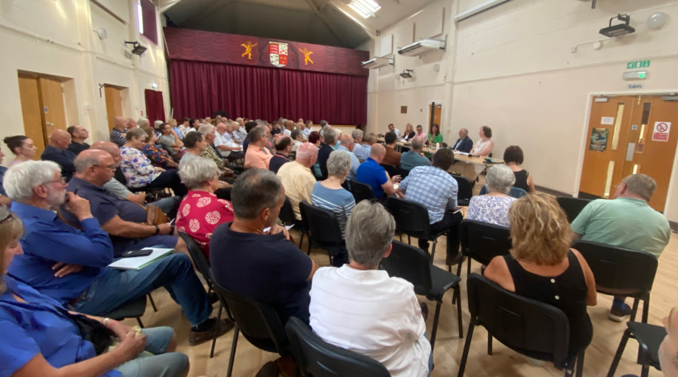
The event in Langham Village Hall on the 13th June was attended by 75 people, who heard questions posed to the panel from CALC members and the floor. Town and parish councils and electors were invited.

Statements were read out from MP’s Pam Cox and Priti Patel, and Anglian Water and questions answered by Sir Bernard Jenkin ( Conservative), Cllr Tim Young (Labour), chair of the Local Plan Committee, Cllr Amy Taylor-Kirby (Green Party) member of Local Plan Committee, Cllr Sara Naylor the Council’s representative on East Suffolk & North Essex NHS Foundation Trust and City and County Cllr Lewis Barber on behalf of ECC Highways.

A robust debate, chaired by Rosie Pearson of Community Planning Alliance, heard very strong concerns raised over the extent, number and location of the additional 11000 homes and over the problems of a lack of hospital facilities, the capacity of the road network, and the inability of sewage treatment works to cater for the new houses. Residents also raised worries about impacts on farmland, countryside, rivers and nature.

The consensus was that whilst additional houses were needed in Colchester consideration must be given by the Council to ensure, that infrastructure must come before housing.

With the publication of the Council’s draft Consultation Preferred Options Plan on hold as work to prepare an Infrastructure Delivery Plan gathers pace the meeting clearly made its feelings known to its elected representatives at City, County and Parliamentary level and CALC looks forward to reviewing the plans in due course too.

Brian Butcher
Chair, Colchester Association of Local Councils calc.clerk@gmail.com
-------------
The Association brings together 31 parish and town councils in Colchester, as a voice to help influence decisions taken by Colchester City Council that affect member Councils either individually or as a whole, to share experiences and concerns, appoint representatives to the Local Highway Panel, the Essex Association of Local Councils and CCC’s Governance Committee.

